Outline on 11/19

* The Practical Significance of The Average Marginal Distinction
* Measuring Cost
  + Accounting Cost: actual expenses plus depreciation charges for capital equipment (Explicit cost)
  + Economic Cost: cost to affirm of utilizing economic resources in production, opportunity cost (Explicit + Implicit cost)
  + Sunk cost: Expenditure that has been made and cannot be recovered.
    - Because a sunk cost cannot be recovered, it should not influence the firm’s decisions
* Fixed Costs and Variable Costs
  + Total cost (TC or C): Total economic cost of production, consisting of fixed and variable costs
  + Fixed cost (FC):
  + Cost that does not vary with the level of output and that can be eliminated only by shutting down.
  + Variable cost (VC): Cost that varies as output varies.
* Marginal and Average Cost:
  + Marginal cost (MC): Increase in cost resulting from the production of one extra unit of output.
    - Because fixed cost does not change as the firm’s level of output changes, marginal cost is equal to the increase in variable cost or the increase in total cost that results from an extra unit of output.
  + We can therefore write marginal cost as 
  + Average total cost (ATC): Firm’s total cost divided by its level of output
  + Average fixed cost (AFC): Fixed cost divided by the level of output
  + Average variable cost (AVC): Variable divided by the level of output
* Diminishing Marginal Returns and Marginal Cost
  + Diminishing marginal returns means that the marginal product of labor declines as the quantity of labor employed increases.
  + As a result, when there are diminishing marginal returns, marginal cost will increase as output increases.
  + 
* Economies and Diseconomies of Scale
  + Economies of scale: Situation in which output can be doubled for less than a doubling of cost.
  + diseconomies of scale: Situation in which a doubling of output requires more than a doubling of cost.

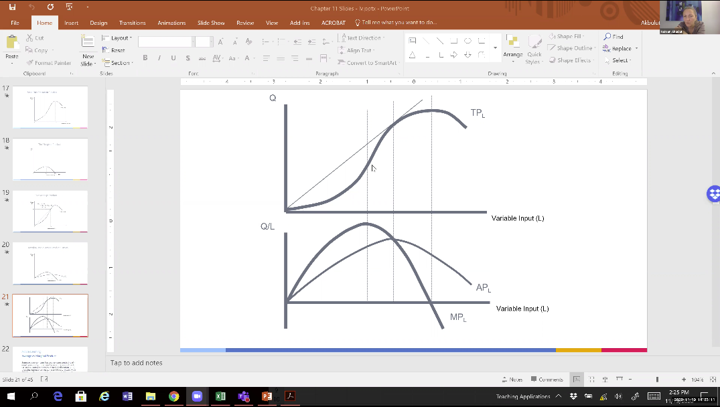

Answer:



